How to update the firmware for the KA17
注意：在为KA17升级固件之前，请拔掉电脑上USB接口的其他解码器！
Note: Before upgrading the firmware for KA17, please unplug other decoders from the USB interface on the computer!

1、安装Windows驱动：https://bbs.fiio.com/note/showNoteContent.do?id=201911191752415983705&tid=16
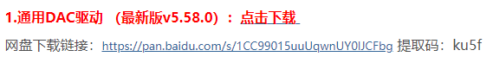
- Install the Windows driver: https://forum.fiio.com/note/showNoteContent.do?id=202105191527366657910&tid=17
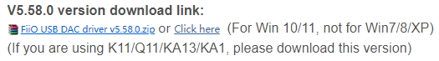

2、将KA17与Windows电脑连接。为了避免因电脑USB接口供电不足导致升级失败，尽量选择电脑后面板的USB接口进行升级。
2. Connect KA17 to the Windows computer. In order to avoid upgrade failure due to insufficient power supply of the computer USB interface, try to choose the USB interface on the back panel of the computer for upgrade.

3、升级前请把KA17的D.MODE开关选择为OFF状态，不要播放音乐；在升级固件的时候，不要晃动USB数据线，以免升级失败。
3. Before upgrading, please select the D.MODE switch of KA17 to the OFF state and do not play music; when upgrading the firmware, do not shake the USB data cable to avoid upgrade failure.

4、双击“FiiO_Dfu_KA17”打开烧录工具，选择“Fiio_KA7_xmos_V134_dfu_V84.bin”，之后点击Start进行升级。
4. Double-click "FiiO_Dfu_KA17" to open the burning tool, select "Fiio_KA7_xmos_V134_dfu_V84.bin", and then click Start to upgrade.
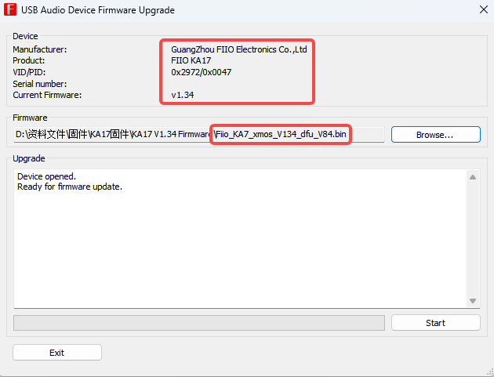

5、当出现“Firmware upgrade finished successfully”时，可以将KA17拔下，再连接USB线，此时KA17的屏幕会出现“升级中，预计需三分钟，请勿拔USB”的升级弹窗，请耐心等待升级完成。当升级完成后，屏幕会出现“升级完成”的字样，即表示KA17固件升级成功。
5. When "Firmware upgrade finished successfully" appears, you can unplug KA17 and then connect the USB cable. At this time, the upgrade pop-up window "Upgrading in progress, estimated to take three minutes, please do not unplug USB" will appear on the screen of KA17. Wait patiently for the upgrade to complete. When the upgrade is completed, the words "Upgrade Complete" will appear on the screen, indicating that the KA17 firmware upgrade is successful.

6、固件升级成功后，可以重新拔插KA17，之后可以在Fiio控制面板中看到固件版本号。
6. After the firmware upgrade is successful, you can re-plug the KA17, and then you can see the firmware version number in the Fiio control panel.
